WCSA Wesleyan Council on Student Affairs | 2015

02/09/2015 Full Senate Minutes
Secretary:
- Role Call
- Placards
- Reports

President:
Dinner tonight at Prichard House @ 6:00pm
- Dress: Business casual
Archway is tomorrow
- Topics: Board of Tustees Dinner, Gender Inclusive Housing
  - Travel Opportunities: Emma
  - Expansion on EMF program: Graham
  - Smoking Policy: Jerry
  - Academic Forums with university Officers
Resolution for Gender Inclusive Housing information- we want to postpone the resolution because we don’t have the university officers support yet. We do like the proposal but the proper process needs to be done before we show support
Golden Bishop Awards: April 18. Nominations will be at a later date.
- Best New Member
- Best Overall Member
- Friend of WCSA Award

Vice President:
Board of Trustees- Really unique opportunity, want to talk about more general and important subjects.
Sexual Assault Survey- Please fill it out to provide information to the University
Orientation Leaders Deadline extended- Really good way to introduce WCSA to freshmen
Meeting with Dan Hitchell- The food points plan is not yet set in stone
Speaker today- Dr. White

Academic Affairs:
- Discussed goals of the committee
- Follow up with Dean Marty Eisenberg about Online homework concern
- Meaghan will email Marty Eisenberg about filling spots on Student Faculty committees. – Number one priority.
- Try and find a solution to get cheaper textbooks? – Year long goal – longer discussions
- Templates from grads and Online Auditing – Follow up with the registrar for privacy issues and advisor issues? Check with Jerry and then proceed.
- Library timings – Do we really need change? 24 hours lounge – not many people use it. Weekends – extend early hours.

Campus Relations:
-Had a successful first meeting last week! Talked about our goals for this term

-Made a WCSA instagram account-- make sure you follow it and tell others to follow it as well!
-Working on developing a plan to remedy over-programming on our campus

Residential Affairs:
Sweatshirt ideas:
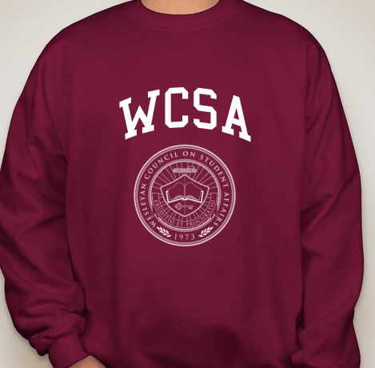
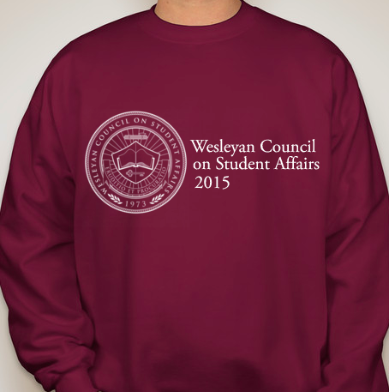
SLU presentations: All SLU’s need to present in order to get their SLU renewed. WCSA members need to be present. This Wednesday from 3-4 and Thursday from 1-3.
Treasurer:
- Goals
  - Definitive location for Budgetary Guidelines
  - Structured WCSA budget spreadsheet
  - Ambiguity of organizations such as BOMI and Pre-Law
  - Work on Updating the Budgetary Guidelines to recent changes
  - Office Hours
  - Meeting with Clubs
  - Maybe more BMS?
  - Discuss raising Student Activity Fee
- 5 club representatives showed up to discuss their requests
  - Sisters, Pride, VegClub, Tauheed, Women’s Rugby
    - Womens Rugby
      - Requested for travel, vans, coach salary, away tournament, home tournament, officials, and field maintenance
      - Requested: $7,525.38
      - Funded: $6,663.60
      - Unanimous vote to fund at 90% minus items that were requested that are provided in the club’s medical kit
      - All in favor, two abstaining
    - Tauheed
      - Requested for 10 new prayer mats
      - Requested: $140
      - Funded: $126
      - unanimous vote to fund at 90% of request for prayer mats
        - One voter had to abstain
    - Pride
      - Heard from Pride on previous budget request of $16,816.00
      - Request for Janet Mock was deferred and still is due to lack of information, awaiting new request
    - Sisters
      - Heard from Sisters United about Jan 5th request of $10,160 to clear up mathematical typos and lack of information
      - Request will be reviewed at next budget meeting
    - VegClub
      - Requested for screening of “Supersize Me” documentary
      - Requested: $320
      - Funds from previous screening of “Food Inc.” will be used
- Next meeting will review Previous requests with inadequate information, as well as review other requests that have since been deferred.

APC:
- No report

Advisor:
- List of people who RSVP to dinner tonight
- Still need program and table seating
- Saga of the hydration stations continues. Received list of actual locations where they will be placed. Planning to install them over break if the locations are approved
- Reminder to fill out campus climate survey
- Research for budget committee- benchmark work with club sports and funding analysis
- Sweatshirts look great, need to be paid for individually

New Business:
- Postponement of Gender Inclusive Housing Resolution- postponed indefinitely
- Budget allocations- detailed in Treasurer report
- Nomination for new at large member- Diana Muzino- All in favor, One abstention
- Diana White- Chair of APC, looks at all things related to curriculum. Currently looking at academic calendar. Two week Spring break, one week fall break with one week Thanksgiving break, no change, wanting feedback on pros/cons of changing or not changing the academic calendar. Won’t generate absolute schedule without adequate feedback. Request came from faculty to look at calendar. Next change would be 2016-2017 because 2015-2016 calendar is already in place. Want information/feedback on the 15th to discuss at meeting on the 17th.

