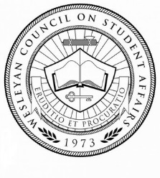
14F-03
2014 Fall

The Wesleyan Council
on Student Affairs

Student Code of Conduct (Sexual Misconduct and Harassment) Resolution 2014

A Resolution Providing Approbation to Changes to the Sexual Misconduct and Harassment Policies Contained in the Student Code of Conduct

(Committee on Administrative Policy)

Presented – 08 September 2014
Agreed to –

Signed,

Matthew McCord
Resolution Sponsor
A Resolution Providing Approbation to Changes to the Sexual Misconduct and Harassment Policies Contained in the Student Code of Conduct
The Wesleyan Council on Student Affairs Resolves:
1 Short title
This Resolution may be cited as the Student Code of Conduct (Sexual Harassment and Misconduct) Resolution 2014.
2 Approbation of changes
The proposed changes to the Student Code of Conduct policies and procedures on Sexual Misconduct and Harassment, resultant of modifications to Federal Title IX, stand reviewed and approved.

Certified and Signed,

Lauren A. Holler
President, Wesleyan Council on Student Affairs

